Ideation Phase

Define the Problem Statements

|  |  |
| --- | --- |
| Date | 18 October 2022 |
| Team ID | PNT2022TMID31228 |
| Project Name | Project - Detecting Parkinson’s Disease using Machine Learning. |
| Maximum Marks | 2 Marks |

Customer Problem Statement:

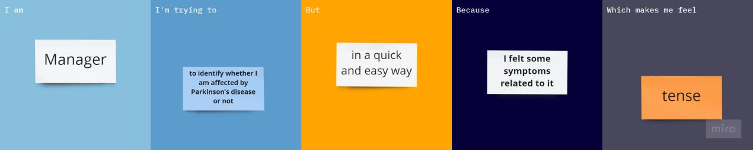

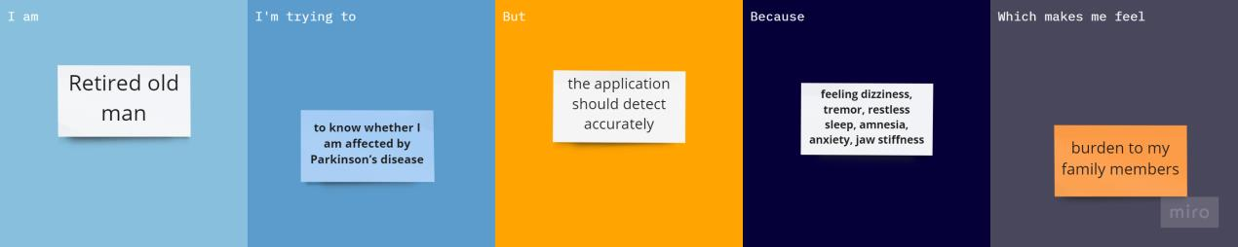

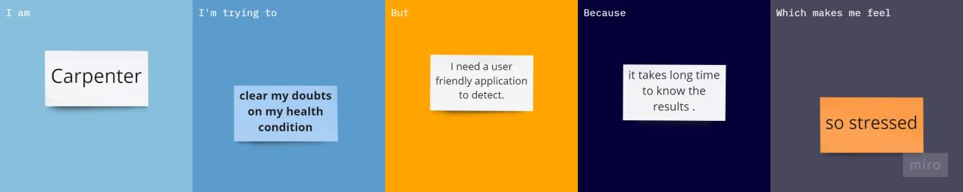

# PROBLEM STATEMENTS:

1. **Sita is a busy manager who needs to identify whether she is affected by Parkinson’s disease or not as she felt some symptoms related to it, if it is identified earlier then she can get treatment at the earliest.**
2. **Ganapathy is an old man having age of around 60 is feeling dizziness, tremor, restless sleep, amnesia, anxiety, jaw stiffness. He wants to**

know whether he is affected by Parkinson’s disease before he reaches to any conclusions so that he can take appropriate medications to improve the life span.

1. **Bob is a carpenter who assumes to have a Parkinson’s disease, so he is trying to clear his misunderstandings to reduce the stress and other factors that is affecting him.**
2. **Abhijit is a retired person who is having similar symptoms to the**

Parkinson’s disease he is looking for a way to know whether he is

affected by Parkinson’s disease or not at the earliest so that he can get treated accordingly to ease the effects of that disease and to improve quality of life.

1. **Kenny is a working woman wants to know whether she is affected by Parkinson’s disease so that she can consult for early medications.**

# INSIGHTS FROM PROBLEM STATEMENTS:

|  |  |
| --- | --- |
| **Who does the problem affect?** | **Men are slightly more likely to get affected by Parkinson’s disease compared to women.** |
| **What are the boundaries of the problem?** | **People usually develop the disease around age 60 or older.** |
| **What is the impact of the issue?** | **Parkinson's disease is caused by a loss of nerve cells in part of the brain called the substantia nigra. This leads to a reduction**  **in a chemical called dopamine in the brain.** |
| **What impact is the issue causing?** | **Motor symptoms: slow movement, tremor, rigidity, walking and imbalance. Non-motor complications: cognitive impairment, mental health disorders,**  **sleep disorders and pain and other sensory disturbances.** |
| **When does it need to be fixed?** | **It needs to be fixed at the earliest when the suspected symptoms like soft or low voice, tremors, lack of facial expression and so on occur.** |
| **What would happen if we**  **didn’t solve the problem?** | **Does not directly cause people to die, but the condition can place great strain on the body and can make some people more**  **vulnerable to serious and life-threatening infections.** |
| **Where is the issue is occurring?** | **The most prominent signs and symptoms occur when nerve cells in the basal ganglia that control movement become impaired or die.** |
| **Why is it important that we fix the problem?** | **By early detection of disease makes the people to take proper diagnosis on time to improve the quality of life of patients.** |